Chapter 17, Solution 43.

(a) V_{rms} = 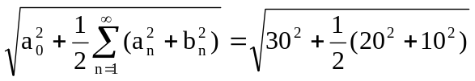 = 33.91 V

(b) I_{rms} = 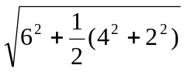 = 6.782 A
- P = V_{dc}I_{dc} + 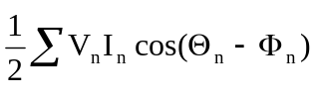
= 30x6 + 0.5[20x4cos(45º-10º) – 10x2cos(-45º+60º)]

= 180 + 32.76 – 9.659 = 203.1 W

